Chapter 4 Activity
Maria Sandate
2025-01-30

In-Class Activity: Chapter 4
A collector of antique grandfather clocks sold at auction believes that the price received for the clocks depends on both the age of the clocks and the number of bidders at the auction. A sample of 32 auction prices of grandfather clocks, along with their age and the number of bidders, is given in GFCLOCKS.
# Load data
CARP <- read.table("GFCLOCKS.txt", header = TRUE, sep = "", stringsAsFactors = FALSE)

(a) Use scattergrams to plot the sample data. Interpret the plots.
library(ggplot2)
## Warning: package 'ggplot2' was built under R version 4.4.2
library(dplyr)
## Warning: package 'dplyr' was built under R version 4.4.2
##
## Adjuntando el paquete: 'dplyr'
## The following objects are masked from 'package:stats':
##
## filter, lag
## The following objects are masked from 'package:base':
##
## intersect, setdiff, setequal, union
# Scatterplot: Price vs Age
ggplot(CARP, aes(x = AGE, y = PRICE)) +
geom_point() +
labs(title = "Scatterplot: Price vs Age", x = "Age of Clock", y = "Auction Price")
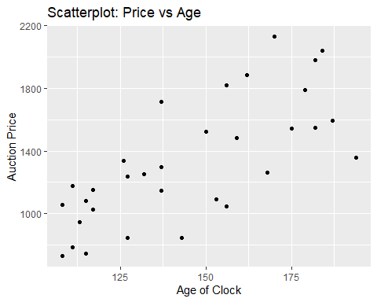
# Scatterplot: Price vs Number of Bidders
ggplot(CARP, aes(x = NUMBIDS, y = PRICE)) +
geom_point() +
labs(title = "Scatterplot: Price vs Number of Bidders", x = "Number of Bidders", y = "Auction Price")
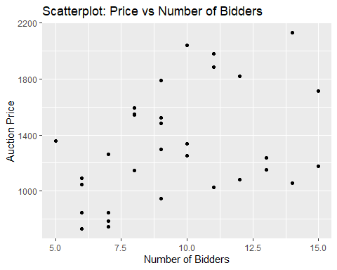

(b) Use the method of least squares to estimate the unknown parameters β0, β1, and β2 of the model.
model <- lm(PRICE ~ AGE + NUMBIDS, data = CARP)
summary(model)
##
## Call:
## lm(formula = PRICE ~ AGE + NUMBIDS, data = CARP)
##
## Residuals:
## Min 1Q Median 3Q Max
## -206.49 -117.34 16.66 102.55 213.50
##
## Coefficients:
## Estimate Std. Error t value Pr(>|t|)
## (Intercept) -1338.9513 173.8095 -7.704 1.71e-08 ***
## AGE 12.7406 0.9047 14.082 1.69e-14 ***
## NUMBIDS 85.9530 8.7285 9.847 9.34e-11 ***
## ---
## Signif. codes: 0 '***' 0.001 '**' 0.01 '*' 0.05 '.' 0.1 ' ' 1
##
## Residual standard error: 133.5 on 29 degrees of freedom
## Multiple R-squared: 0.8923, Adjusted R-squared: 0.8849
## F-statistic: 120.2 on 2 and 29 DF, p-value: 9.216e-15

(c) Find the value of SSE that is minimized by the least squares method.
SSE <- sum(resid(model)^2)
SSE
## [1] 516726.5

(d) Find the MSE (mean square error) and Root MSE. What is the root MSE?
MSE <- SSE / df.residual(model)
MSE
## [1] 17818.16
Root_MSE <- sqrt(MSE)
Root_MSE
## [1] 133.4847

(e) Is the regression model appropriate here? Write down the null and alternative hypothesis and make your conclusion based on the appropriate test.
anova(model)
## Analysis of Variance Table
##
## Response: PRICE
## Df Sum Sq Mean Sq F value Pr(>F)
## AGE 1 2555224 2555224 143.406 9.527e-13 ***
## NUMBIDS 1 1727838 1727838 96.971 9.345e-11 ***
## Residuals 29 516727 17818
## ---
## Signif. codes: 0 '***' 0.001 '**' 0.01 '*' 0.05 '.' 0.1 ' ' 1
Null Hypothesis (H0): The model is not significant.
Alternative Hypothesis (HA): At least one predictor significantly affects the auction price.

(f) Test the hypothesis that the mean auction price of a clock increases as the number of bidders increases when age is held constant.
summary(model)$coefficients["NUMBIDS", ]
## Estimate Std. Error t value Pr(>|t|)
## 8.595298e+01 8.728523e+00 9.847368e+00 9.344953e-11

(g) Form a 95% confidence interval for β1 and interpret the result.
confint(model, level = 0.95)
## 2.5 % 97.5 %
## (Intercept) -1694.43162 -983.47106
## AGE 10.89017 14.59098
## NUMBIDS 68.10115 103.80482

(h) Estimate the average auction price for all 150-year-old clocks sold at auctions with 10 bidders using a 95% confidence interval. Interpret the result.
new_data <- data.frame(AGE = 150, NUMBIDS = 10)
predict(model, new_data, interval = "confidence", level = 0.95)
## fit lwr upr
## 1 1431.665 1381.398 1481.931

(i) Predict the auction price for a single 150-year-old clock sold at an auction with 10 bidders using a 95% prediction interval. Interpret the result.
predict(model, new_data, interval = "prediction", level = 0.95)
## fit lwr upr
## 1 1431.665 1154.069 1709.26

(j) Suppose you want to predict the auction price for one clock that is 50 years old and has two bidders. How should you proceed?
new_data2 <- data.frame(AGE = 50, NUMBIDS = 2)
predict(model, new_data2, interval = "prediction", level = 0.95)
## fit lwr upr
## 1 -530.0167 -901.2106 -158.8227

(k) Test the hypothesis that age and number of bidders interact positively.
model_interaction <- lm(PRICE ~ AGE * NUMBIDS, data = CARP)
summary(model_interaction)
##
## Call:
## lm(formula = PRICE ~ AGE * NUMBIDS, data = CARP)
##
## Residuals:
## Min 1Q Median 3Q Max
## -154.995 -70.431 2.069 47.880 202.259
##
## Coefficients:
## Estimate Std. Error t value Pr(>|t|)
## (Intercept) 320.4580 295.1413 1.086 0.28684
## AGE 0.8781 2.0322 0.432 0.66896
## NUMBIDS -93.2648 29.8916 -3.120 0.00416 **
## AGE:NUMBIDS 1.2978 0.2123 6.112 1.35e-06 ***
## ---
## Signif. codes: 0 '***' 0.001 '**' 0.01 '*' 0.05 '.' 0.1 ' ' 1
##
## Residual standard error: 88.91 on 28 degrees of freedom
## Multiple R-squared: 0.9539, Adjusted R-squared: 0.9489
## F-statistic: 193 on 3 and 28 DF, p-value: < 2.2e-16

(l) Test the overall utility of the model using the global F-test at α = .05.
anova(model)
## Analysis of Variance Table
##
## Response: PRICE
## Df Sum Sq Mean Sq F value Pr(>F)
## AGE 1 2555224 2555224 143.406 9.527e-13 ***
## NUMBIDS 1 1727838 1727838 96.971 9.345e-11 ***
## Residuals 29 516727 17818
## ---
## Signif. codes: 0 '***' 0.001 '**' 0.01 '*' 0.05 '.' 0.1 ' ' 1

(m) Test the hypothesis (at α = .05) that the price–age slope increases as the number of bidders increases—that is, that age and number of bidders, x2, interact positively.
summary(model_interaction)$coefficients["AGE:NUMBIDS", ]
## Estimate Std. Error t value Pr(>|t|)
## 1.297846e+00 2.123326e-01 6.112325e+00 1.353474e-06

(n) Estimate the change in auction price of a 150-year-old grandfather clock, y, for each additional bidder.
summary(model)$coefficients["NUMBIDS", ]
## Estimate Std. Error t value Pr(>|t|)
## 8.595298e+01 8.728523e+00 9.847368e+00 9.344953e-11

